

FNMS Analytics Install Guide
Document History

Date | Revision | Description | Author(s)
5 October 2021 | 1.0 | Initial revision | Trevor Holmes

Initial Configuration
REF:
To install and configure FNMS Analytics on an existing FNMS 2021-R1 system:
- Create a folder FNMSCognosAnalytics and copy into it:
  - The contents of the source folder .\FlexNet Manager Suite\Support
  - The Cognos installer binary ca_srv_win64+11.0.13.19121917.exe
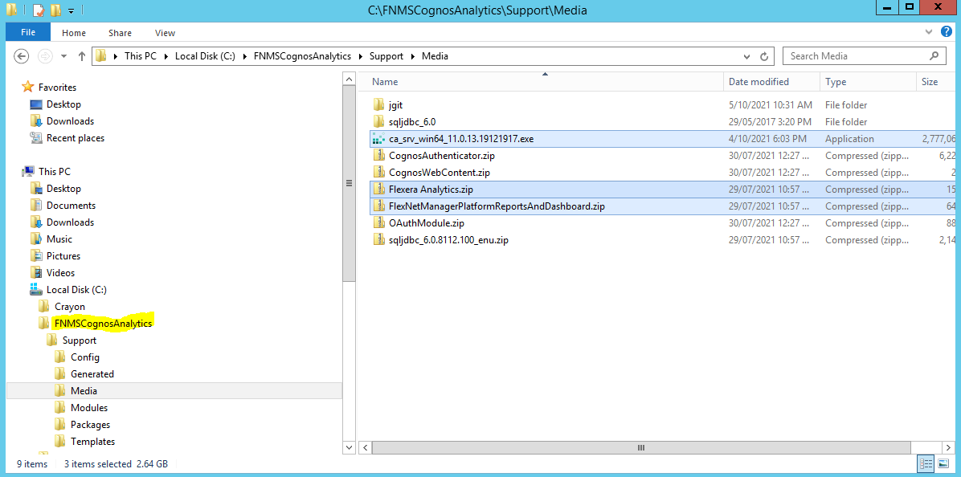
- Edit the entries in the CognosCOnfigProperties.xml file:
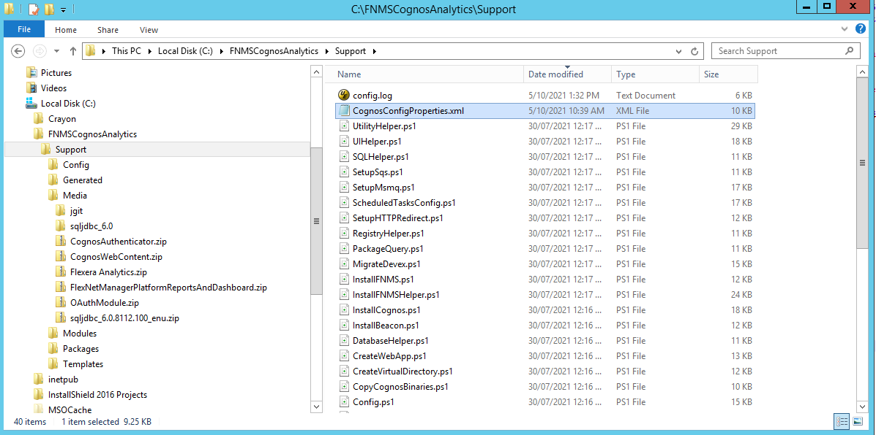

- Open a PowerShell console (as Administrator), change directory to
C:\FNMSCognosAnalytics\support, and run
.\InstallCognos.ps1
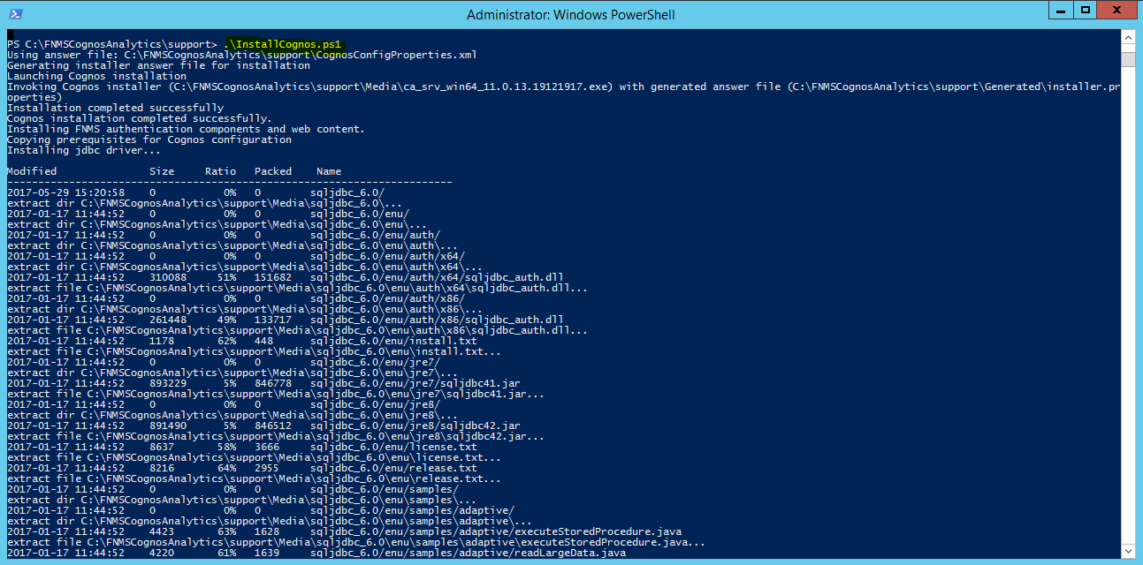
You may be prompted to install Application Request Routing. If so, download it and run the
web installer.
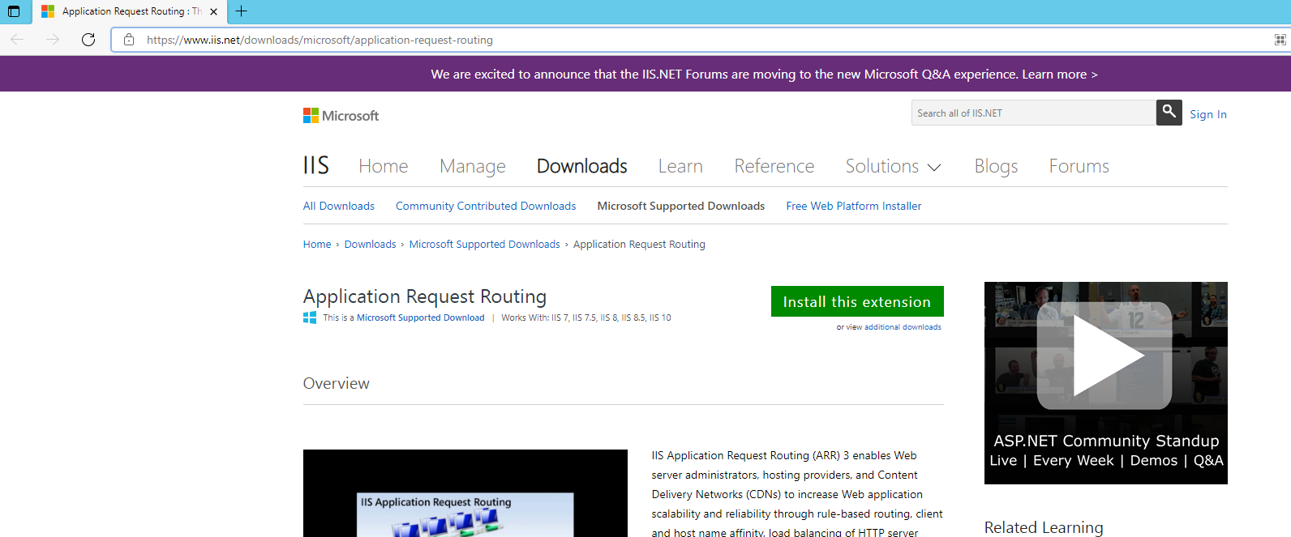
- The install will run for a long while, but check that it completes cleanly
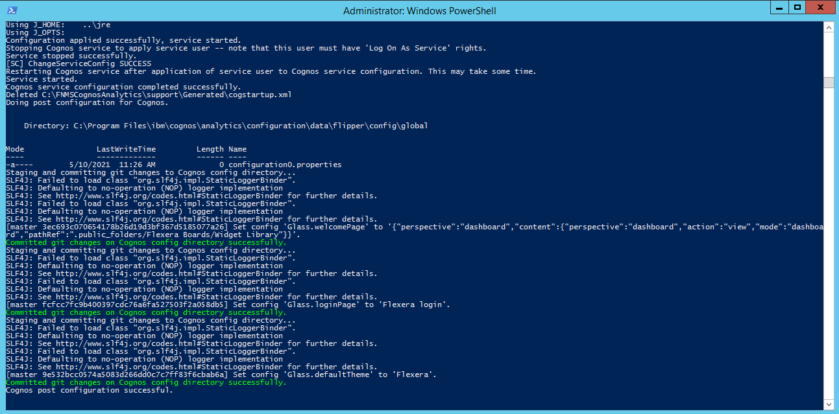
- Next, run the command line:
.\Config.ps1 ‘.\config\FNMS Cognos Config.xml’ updateconfig
to configure the Analytics menu links in FNMS

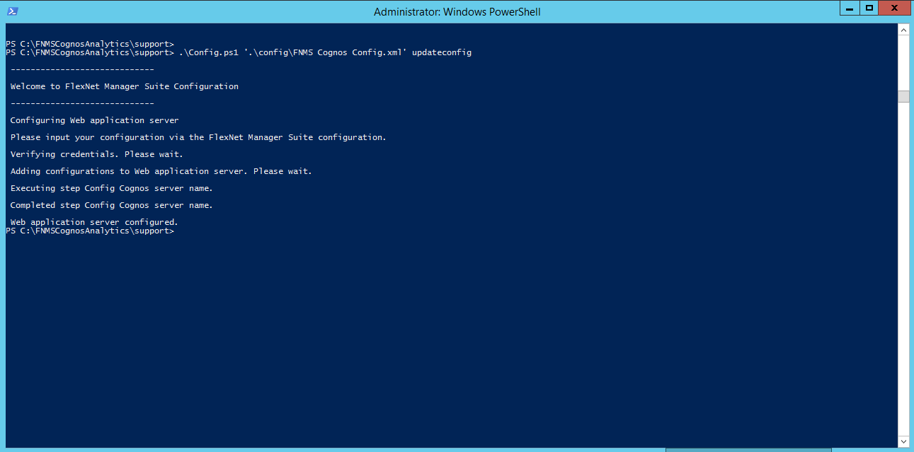

- Run the Flexera package importer: CognosPackageImport.exe

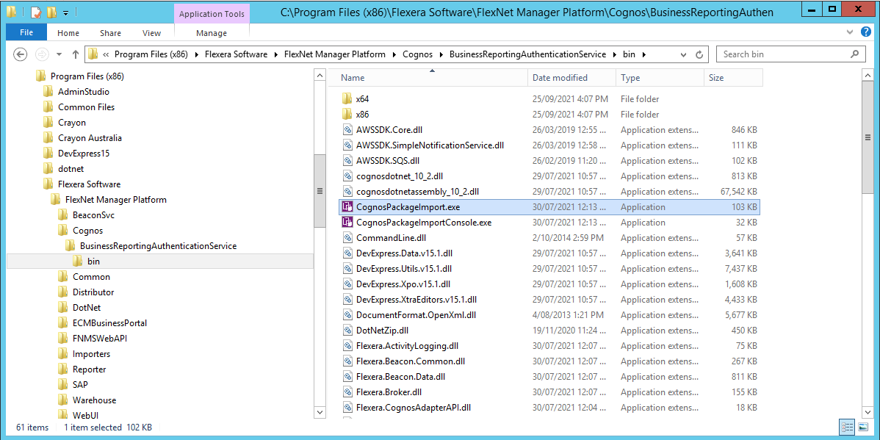

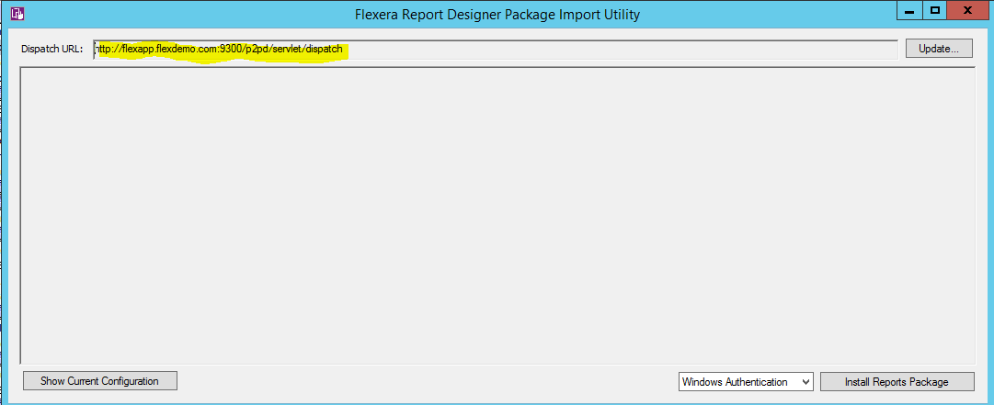
You can get the Dispatcher URL from the CogConfig tool:
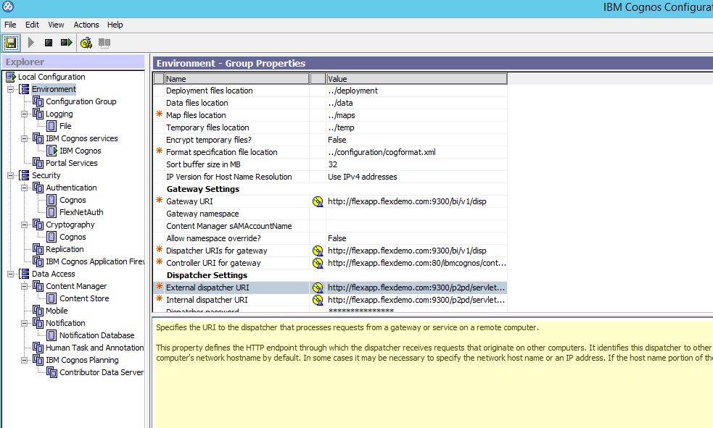
- Finally run the package import
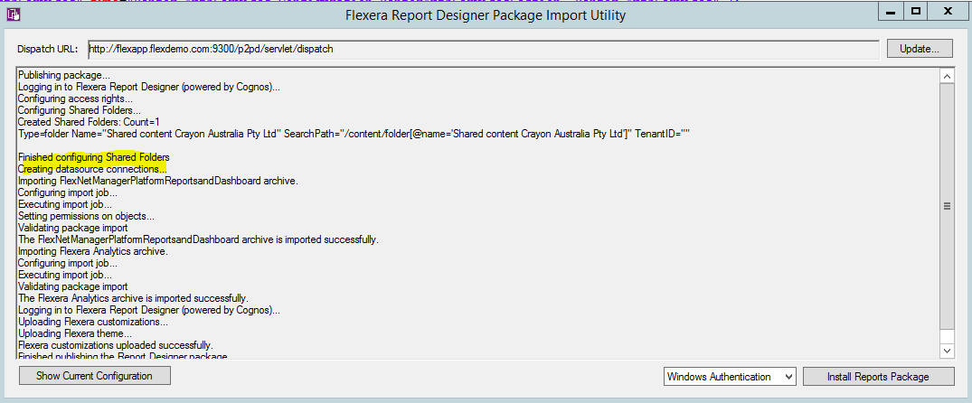

- Make sure that your Users have Admin rights
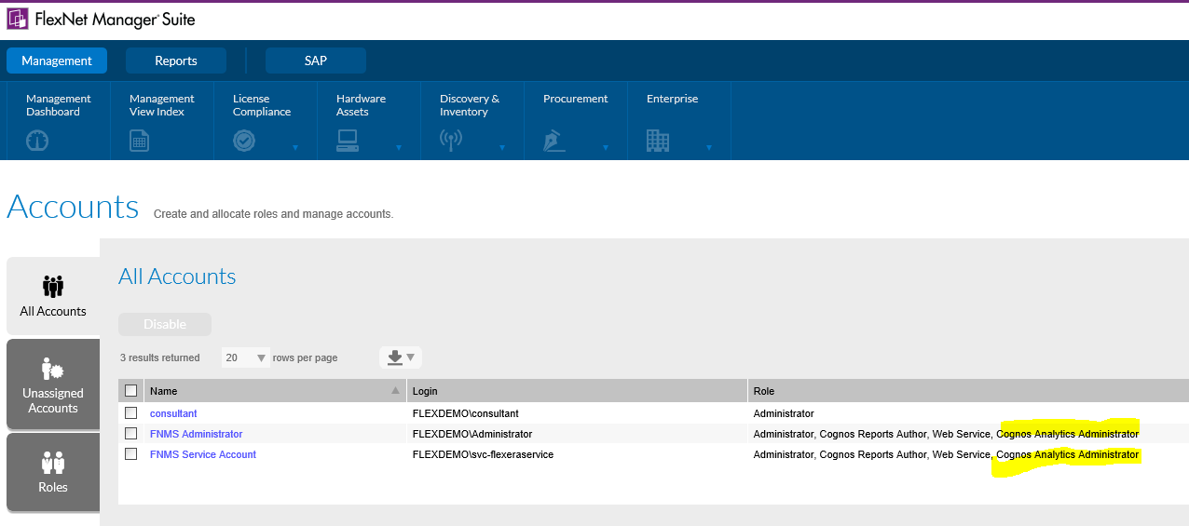

- If all is OK, you should be able to see Analytics in FNMS
